**URL:**

<https://www.youtube.com/watch?v=n42nFDTkTCI&list=PLdpzxOOAlwvLNOxX0RfndiYSt1Le9azze&index=14>

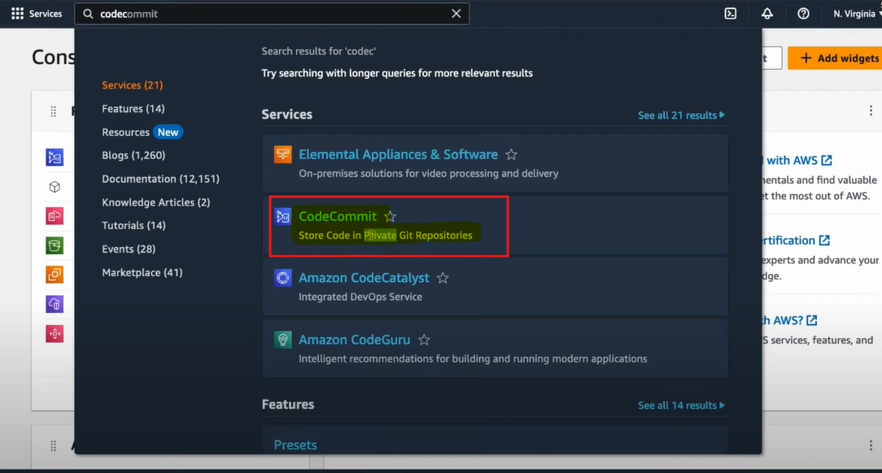

**🡺 Upload File manually process**

**Uploading Files via Terminal Using IAM User (Not Root Account)**

When working with AWS through the terminal, it's important **not** to use the **root account**. AWS strongly **discourages** using the root user for any day-to-day operations, including cloning repositories or uploading files.

Even if you attempt to use the root account, you’ll face limitations — for example, **SSH cloning isn’t supported** with the root user, and while HTTPS cloning may work, it is **not a secure or recommended option**.

Instead, the right approach is to use an **IAM (Identity and Access Management) user**. Here's how:

1. **Create an IAM User** in the AWS Management Console.
2. **Attach appropriate permissions** (such as AmazonS3FullAccess or a custom policy for specific actions like S3 uploads or Git access).
3. **Generate and configure credentials** (Access Key ID and Secret Access Key).
4. **Use AWS CLI** on your terminal:
   * Run aws configure and input the IAM credentials.
   * Now you can securely **upload files**, **clone repositories**, or perform other actions via the terminal.

✅ This method ensures **security**, **best practices**, and **compliance with AWS guidelines**.

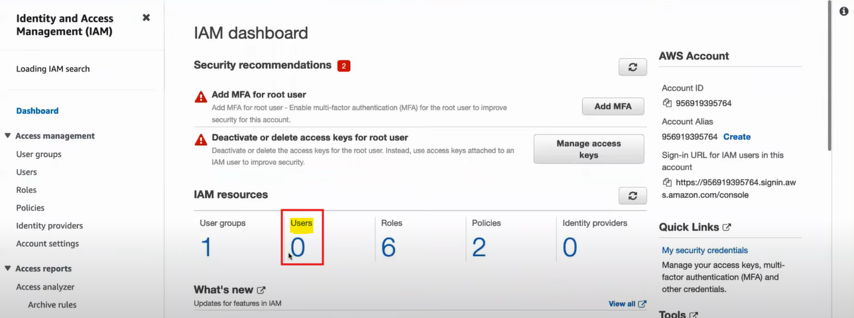

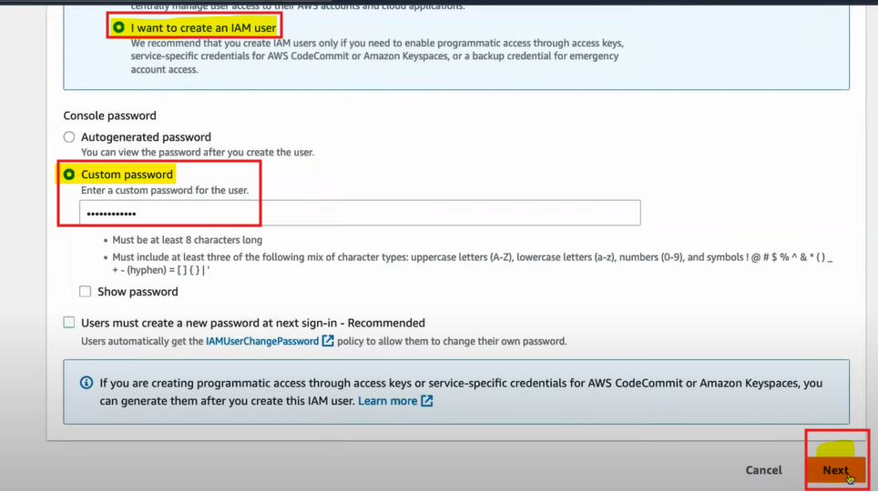

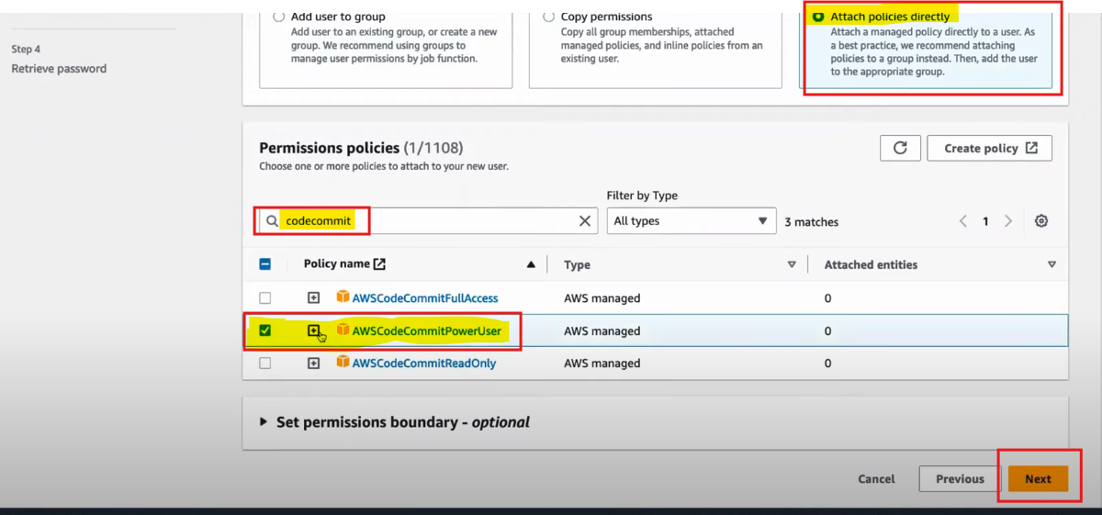

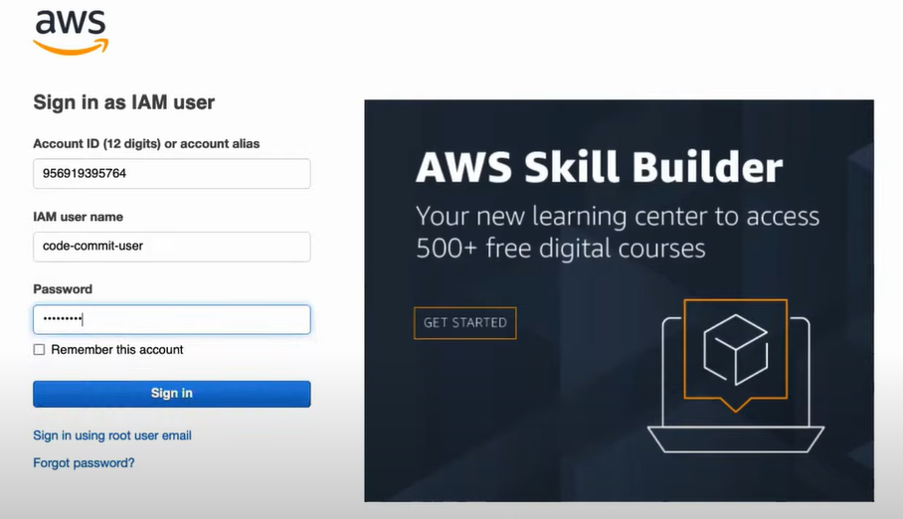

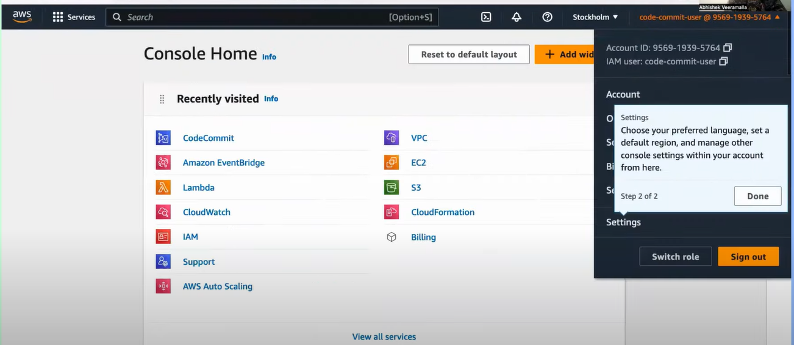

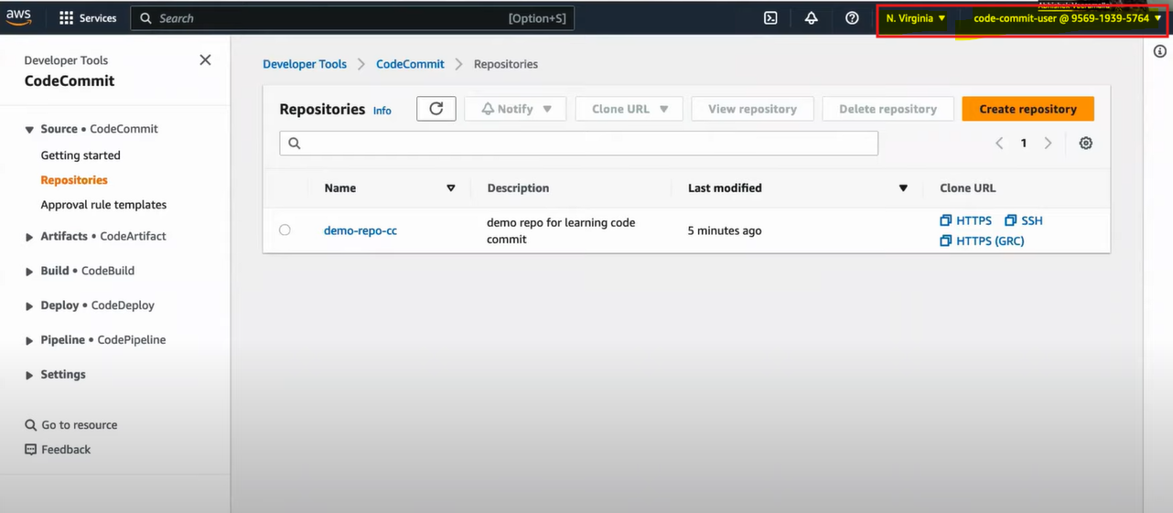

🡺 **We need to install Git**

